**Please connect your charger.**

- Divyanshu Sharma, Bhatai Vidyapeeth College of Engineering

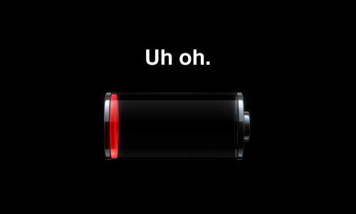

“Kisi ke paas battery bank hai?” is something you might recall hearing 5 times a day as a part of your college routine. The cause, as you might also recall, is the 5 inch 2ish GHz bundle of joy inside your pockets. The smartphone revolution has taken the world by storm, and mobile computing technology is booming at an exponential rate. But as ppi values and cat videos galore, the average up time of a phone today has dropped to a day of moderate usage, from a time where a single charge could last weeks.

This scenario points towards the obvious fact that battery technology, the trusted Lithium-ion based cells, hasn’t been able to keep up with the ever increasing power demands of portable devices. Battery tech is becoming the limiting factor in many of today’s technologies.

According to a survey of more than 1,000 adults, only 2 percent said they were extremely or very likely to buy Internet-connected glasses, such as Google Glass, in 2015, and 4K television didn't do much better. Seventy-five percent of respondents said they had never heard of it. Meanwhile, consumers indicated that the new smartphone feature they were most excited about — picked by 33 percent of respondents — was "improved battery life."

But even though batteries haven’t seen much love over the past years, there are a bunch of new technologies on the horizon to increase the charge storage, reduce the charging time, and to make that little red battery a lesser annoyance.

**StoreDot**

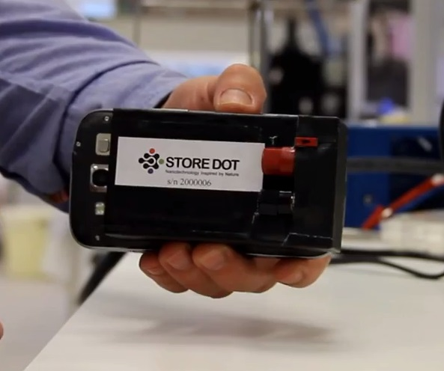

StoreDot gained plenty of attention when it released details about its clever, and very fast, charging system recently. How fast? A Galaxy S4 can go from zero percent to capacity in just 30 seconds, when powered by this impressive tech.

In an attempt to cure Alzheimer disease, Professor Ehud Gazit discovered Peptides (amino acids) that have special qualities - optic and electric, and StoreDot was born.  
  
StoreDot focus on bio-organic nano-crystal technology as an enabler for faster charging batteries and also a cheaper and non-toxic alternative to cadmium in screens.

**Titanium dioxide nanotubes**

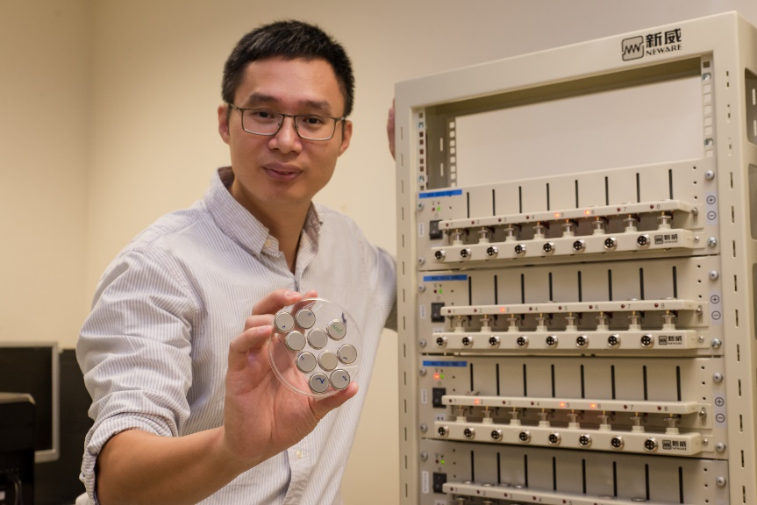

Specifically, the NTU researchers claim this new battery technology has a whopping 10,000-cycle lifespan, meaning you can charge a battery 10,000 times before its max charge starts to reduce.

Enabling the nifty new tricks doesn’t require a full reimagining of how we design batteries, either. The researchers replaced the graphite used in the anode of lithium-ion batteries with a gel made from titanium dioxide nanotubes, a thousand times thinner than the diameter of a human hair.

Using tiny titanium dioxide nanotubes rather than graphite also speeds how quickly electrons and ions flow in and out of the battery, by ditching an energy-slowing additive needed in today’s batteries. The NTU researchers say their battery charges far faster than traditional lithium-ion batteries, going from empty to a 70 percent charge in just two minutes.

**Trontium Reactor**

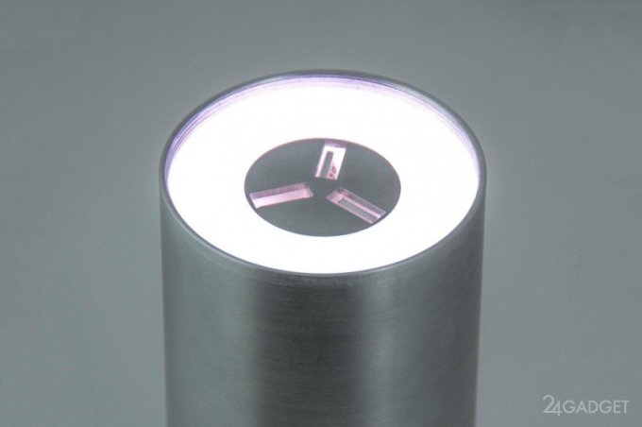

USB Power Delivery is a new standard through which devices with USB ports can ask for an additional power over the standard supplied by USB 3.0. Devices can request up to 20 volts and 5 Amps, resulting in a maximum of 100 watts.

The Reactor has a monster 290 watt-hour battery inside, and three 100 watt-capable USB ports on the top. It doesn’t only charge phones either, it’ll sort out your 13-inch Macbook Air 5 times, or a Surface Pro 2 6 times. With the addition of a special splitter cable, the Reactor can recharge up to 18 phones at the same time from a single USB port.

**Super capacitors**

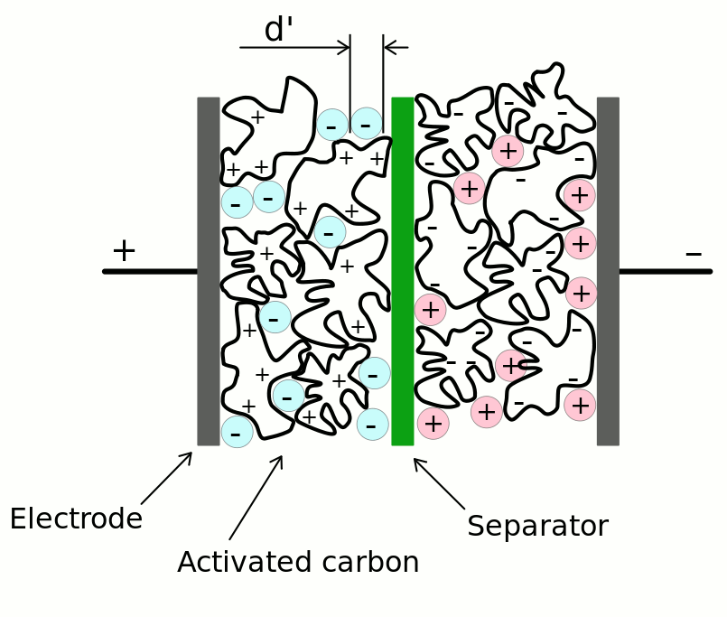

Super capacitors are batteries that fit somewhere in-between regular batteries and rechargeable cells. They can be charged very quickly, store plenty of energy, then send it out over a sensible amount of time. Despite this fast-paced, hard-living lifestyle, the cells aren’t fragile, and can see tens of thousands of charge cycles before they give up.

**Quick Charge 2.0**

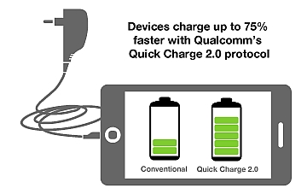

Qualcomm’s Quick Charge 2.0 technology doesn’t extended the life of your battery, but it can make charging one a faster process. Built into its Snapdragon processors, and into specially made wall chargers, Quick Charge 2.0 promises to charge a smartphone battery 75 percent quicker than before. For example, a 3300mAh cell should take just 96 minutes to fully charge, compared to 270 minutes using a conventional charger. The downside is, both your phone and the charger need to have Quick Charge technology as standard, and there’s no backwards compatibility either. 

**20 second charge**



One exciting talent to keep an eye on is Eesha Khare, a Harvard student of Indian origin, who developed an award-winning battery. Her tiny invention can store an impressive amount of energy despite its miniature size, a key factor that could revolutionize smartphone battery technology.

Eesha's 'super capacitor energy storage device' is made of carbon fiber and metal oxides, and the clever nanotech not only charges mobile devices at a faster rate than previously possible, it also holds charge for much longer.

Even though technologies like these instill a sense of optimism in our mind, the actual viability is bleak to say the least. So till then, “Battery bank die!”